Capital Budgeting Project
The vehicles that I have chosen for my capital budgeting project are the 2015 Hyundai Sonata and the 2015 Hyundai Sonata Hybrid. I am planning on keeping my car for 10 years and at the end of the 10th year, the resale value of both models will be negligible.
- Research the cost of each model (include estimated taxes and title costs). Also, obtain an estimate of the miles-per-gallon fuel efficiency of each model.

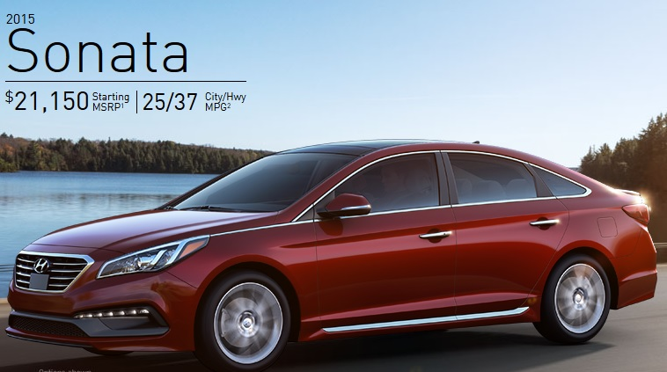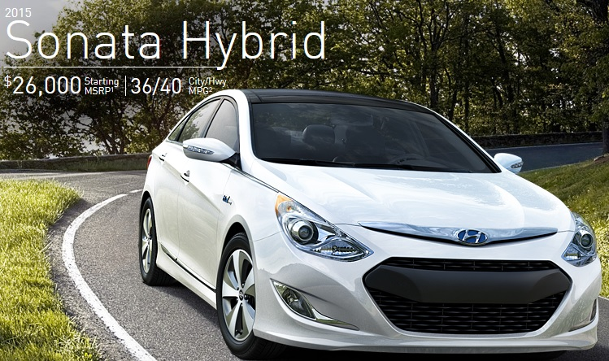

Vehicle Specs
Car | Price | Miles Per Gallon (MPG) | Weight
2015 Hyundai Sonata | $21,150 | 25 City/37 Hwy | 3252 lbs.
2015 Hyundai Sonata Hybrid | $26,000 | 36 City/40 Hwy | 3,508-3,633 lbs.

Additional costs of vehicle
Car | Price | Estimated Tax Cost | Title Cost | Registration Fee | Total Cost Out The Door
2015 Hyundai Sonata | $21,150 | (21,150 x 6%) =$1269.00 | $77.25 | $135.60 | $22631.85
2015 Hyundai Sonata Hybrid | $26,000 | (26,000 x 6%) =$1560.00 | $77.25 | $135.60 | $27772.85
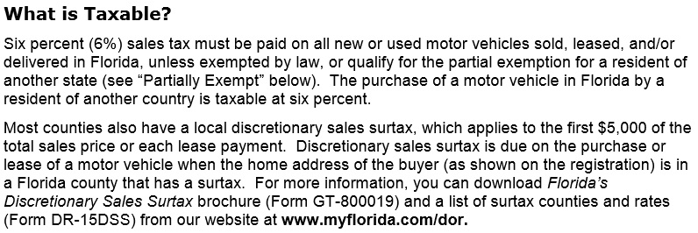
Vehicle registration fees are an initial $100 plus the rate for a vehicle over 2500 pounds ($35.60) for a total of $135.60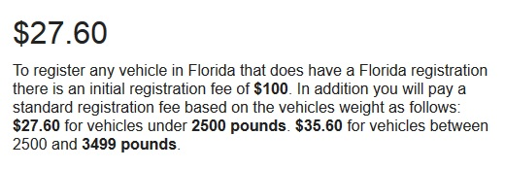

Federal Reserve Bank Prime Loan Rate is currently 3.25%
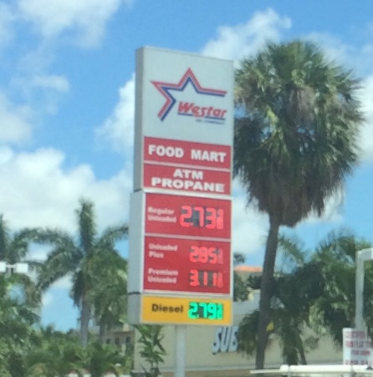
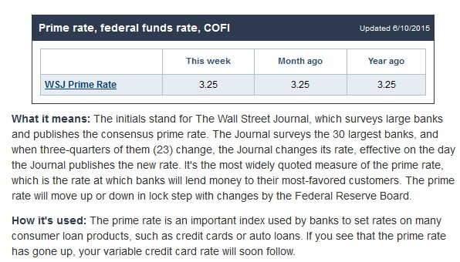
- Estimate the number of miles you drive each year. Also estimate the costs of a gallon of fuel.

The price of gas according to the Westar gas station was $2.73 per gallon for regular unleaded.
Place I’m Going | Average Miles Driven  (Per Week) | Est. Fuel Cost  (Per Gallon) | Weeks  (Per Year) | Total Miles  (Per Year)
Work (5 days) | 20 x 5 = 100 | $2.73 | 52 | 5200
Other | 5 x 7 = 35 | $2.73 | 52 | 1820
 | 135 per week |  | 52 | 7020

- Given your previous estimate from 1 and 2, estimate the total cost of driving the hybrid model for one year. Also estimate the total cost of driving the non-hybrid model for one year. Calculate the savings offered by the hybrid model over the non-hybrid model.
Car | Average Miles Driven  (Per Year) | Average Miles Per Gallon (MPG) | Gallons Used (Per Year) | Est. Fuel Cost  (Per Gallon) | Total Fuel Cost  (Per Year)
2015 Hyundai Sonata | 7020 miles | 25 City+37 Hwy/2 = 31 mpg | 226.45 | $2.73 | 226.45 x 2.73 = $618.21
2015 Hyundai Sonata Hybrid | 7020 miles | 36 City+40 Hwy/2 =  38 mpg | 184.74 | $2.73 | 184.74 x 2.73 = $504.34

Savings of $113.87 per year due to better fuel economy.
($618.21 - $504.34= $113.87)
After 10 years that is $1138.70 in savings! ($113.87 x 10 = $1138.70)

- Calculate the NPV of the hybrid model, using the annual fuel savings as the annual cash inflow for the 10 years you would own the car.

The Net Present value of the hybrid model has equal annual net cash inflows (annual fuel savings) of $113.87, so it is treated as an annuity. According to the text, the present value ratio for annuities at 10 years and 3.25% is 8.53.
So the NPV would be calculated
$113.87 x 8.53 = $971.31 – “initial investment” $27772.85 = ($26801.85)
- Compare the NPV of the hybrid model with cost of the cost of the gasoline-engine model. Which model has the lowest (the lowest NPV)? From a financial standpoint, does the hybrid model make sense?

NPV = Net cash inflows – Initial investment
Hyundai Sonata Hybrid
$113.87 x 8.53 = $971.31 – “initial investment” $27772.85 = ($26801.85) = NPV
Hyundai Sonata
No net cash inflows due to gas savings. 0 – Initial investment = NPV = ($22631.85)
The Hyundai Sonata Hybrid has a lower NPV which makes it undesirable from a financial standpoint.
- Now look at the payback period of the hybrid model. Use the difference between the cost of the hybrid model and the gasoline-engine model as the investment. Use the annual fuel savings as the expected annual net cash inflow. Ignoring the time value of money, how long does it take for the additional cost of the hybrid model to pay for itself through fuel savings?

Payback period of hybrid model: Initial Investment / Annual Net Cash Inflow
$27772.85 / $113.87 = 243.89 years
Cost difference between Hybrid model and regular model is
$27772.85 - $22631.85 = $5141.00
Car cost difference / annual fuel savings = $5141 / $113.87 = 45.15 years
It will take 45.15 years in order for the additional cost of the hybrid model to pay for itself through fuel savings.
- What qualitative factors might affect your decision about which model to purchase?
Whether or not the car was produced in the United States, if I could negotiate a discount price instead of full sticker price, and whether or not I wanted to reduce my carbon foot print and buy the hybrid model.

